Miles Shinsato
Nardos Gebremedhin
Jessica Long-Heinicke
Joseph Ayo
Adrian Marquez
12/7/24

CSD 310 – Group 1

Case Study: Bacchus Winery

Deliverable #1 – Business Rules
1. Supply Chain Management
  - Supplier Monitoring
- All suppliers must provide detailed delivery schedules and update them in real-time if there are changes
- Delivery performance must be reviewed monthly, with no more than 5% variance allowed between expected and actual delivery dates
  - Inventory Levels
- Critical Inventory (bottles, corks, labels, etc.) must be maintained at a minimum of 30 days’ supply, based on average monthly usage
- Low inventory alerts must automatically trigger purchase orders to approved suppliers for restocking
  - Supplier Agreements
- Supplier agreements must include penalties for late deliveries (beyond a 3-day grace period)
- All suppliers must be onboarded into an online procurement system for real-time order placement, shipping tracking, and communication
Assumptions
- Current suppliers are willing to adopt digital processes for tracking and order management
- Inventory restocking frequency will remain monthly unless production increases
2. Distribution and Sales
2.1 Distributor Ordering
- All distributors must use an online portal to place orders, eliminating manual order processes
- Orders must include tracking details (e.g., estimated delivery date, shipment stages) must be visible to both distributors and winery staff in real-time
2.2 Sales Analysis
- Sales data must be reviewed monthly to identify underperforming wines (e.g., those selling less than 50% of their expected sales targets) or high demand products (e.g., those selling out with retailers)
- Discounts and targeted marketing campaigns must be implemented for wines that are underperforming
2.3 Wine Allocation
- Each distributor must be assigned a sales quota per wine type with adjustments made quarterly based on past sales performance and trends
Assumptions
- All distributors have access to internet enabled devices for online order placement and tracking
- Existing marketing strategies can be adapted to focus on underperforming wines
3. Employee Management
3.1 Time Tracking
- All employees must clock in and out through a digital time tracking system ensuring accurate labor hour records
- Any employee working more than 40 hours per week must be flagged for overtime review
3.2 Quarterly Employee Reports
- Quarterly reports on employee hours worked must be generated and shared with department heads for workforce review and planning
3.3 Performance Reviews
- Employee productivity must be evaluated quarterly using tracked hours and output metrics as benchmarks
- Employees with performance issues must participate in performance improvement programs
  - Employee Management
- Employees are to be grouped into departments (Finance, Marketing, Production, Supply Chain
- Departments are to be managed by one employee. No employee can manage more than one department
Assumptions
- Employees will adapt to the new time tracking system with minimal training
- Current labor laws regarding overtime and working hours are adhered to
4. Reporting and Decision Making
4.1 Supplier Reports
- Monthly supplier performance reports must highlight delivery times, delays and order accuracy
4.2 Sales Reports
- Monthly wine sales reports must include data by product and distributor, along with historical trends and performance metrics
4.3 Employee Reports
- Quarterly reports must include detailed breakdowns of hours worked per employee, department productivity, and overtime incurred
Assumptions
- Stan and Davis will review reports monthly and make decisions based on insights provided by these reports

5. Technology Implementation
5.1 System Integration
- All new systems (inventory management, online ordering, time tracking) must integrate into a central dashboard accessible to management
5.2 System Training
- All employees and distributors must undergo training sessions for all new systems to ensure proper adoption and usage
5.3 Data Security
- All digital systems must comply with standard data security standards to protect sensitive information (e.g., customer, supplier, and employee data)
Assumptions
- The winery has the budget and technical capability to implement and maintain these systems
- Employees and distributors will embrace the use of new technology after training
6. Inventory and Supplier Management
6.1 Real-Time Shipment Updates
- Suppliers must provide real-time shipment tracking and notify the winery of any delays exceeding 24 hours
6.2 Seasonal Restocking Adjustments
- Restocking thresholds must account for seasonal demand surges, with a 50% increase in buffer stock during peak periods (e.g., holidays or wine festivals)
6.3 Quality Assurance
- All deliveries must be inspected within 48 hours. Defective or non-compliant items must be reported immediately, with replacements arranged within 7 days
6.4 Automated Reordering
- Inventory levels must trigger automated purchase orders when stock falls below 30 days’ supply, based on average monthly usage
6.5 Supplier Accountability Agreements
- All supplier agreements must include clear accountability measures such as penalties for delays beyond the 3-day grace period and incentives for consistent, on-time performance
Assumptions
- Suppliers are willing and able to adopt digital systems for real-time tracking and communication
- Seasonal demand patterns are predictable based on historical data
- The winery has resources for automated systems and quality assurance processes
- Current storage facilities can handle increased buffer stock during high-demand periods
Deliverable #2 - Entity Relationship Diagram
Visualization:
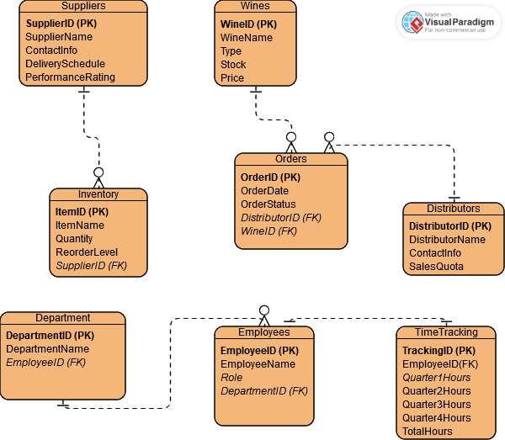
Text Breakdown:
- Suppliers
  - SupplierId (Primary Key)
  - SupplierName
  - ContactInfo
  - DeliverySchedule
  - PerformanceRating
- Inventory
  - InventoryId (Primary Key)
  - ItemName (e.g., bottles, corks)
  - Quantity
  - ReorderLevel (Minimum quantity triggering restock)
  - SupplierId (Foreign Key to Supplier)
- Distributors
  - DSistributorId (Primary Key)
  - DistributorName
  - ContactInfo
  - SalesQuota
- Wines
  - WineId (Primary Key)
  - WineName
  - WineType (e.g., red, white)
  - WineStock
  - Price
- Departments
  - DepartmentId (Primary Key)
  - DepartmentName
  - EmployeeId (Foreign Key)
- Employees
  - EmployeeId (Primary Key)
  - EmployeeName
  - Role (e.g., Finance, Marketing, Production)
  - DepartmentId (Foreign Key)

- TimeTracking
  - TrackingId (Primary Key)
  - EmployeeId (Foreign Key)
  - Quarter1Hours
  - Quarter2Hours
  - Quarter3Hours
  - Quarter4Hours
  - TotalHours

Relationship Breakdowns:
Suppliers to Inventory
One to Many – Each supplier can provide multiple inventory items
Wines to Orders
One to Many – Each wine can appear to multiple orders
Distributors to Orders
One to Many – Each distributor can purchase multiple orders
Employees to Departments
Many to One – Each department can have multiple employees
Employees to TimeTracking
One to One – Each employee can have only one time tracking record that aggregates all quarterly hours during specific time periods

